**Property Management Application Using Salesforce - (Developer) – ( Long-Term)**

ID:  LTVIP2024TMID11592

**Team leader:** N.INDHUMATHI

**Team member:** N.Indhumathi

### Salesforce

## **Introduction:**

Are you new to Salesforce? Not sure exactly what it is, or how to use it? Don’t know where you should start on your learning journey? If you’ve answered yes to any of these questions, then you’re in the right place. This module is for you.

Welcome to Salesforce! Salesforce is game-changing technology, with a host of productivity- boosting features, that will help you sell smarter and faster. As you work toward your badge for this module, we’ll take you through these features and answer the question, “What is Salesforce, anyway?”

## **What Is Salesforce?**

Salesforce is your customer success platform, designed to help you sell, service, market, analyze, and connect with your customers.

Salesforce has everything you need to run your business from anywhere. Using standard products and features, you can manage relationships with prospects and customers, collaborate and engage with employees and partners, and store your data securely in the cloud.

So what does that really mean? Well, before Salesforce, your contacts, emails, follow-up tasks, and prospective deals might have been organized something like this:

[https://youtu.be/r9EX3lGde5](https://youtu.be/r9EX3lGde5k)

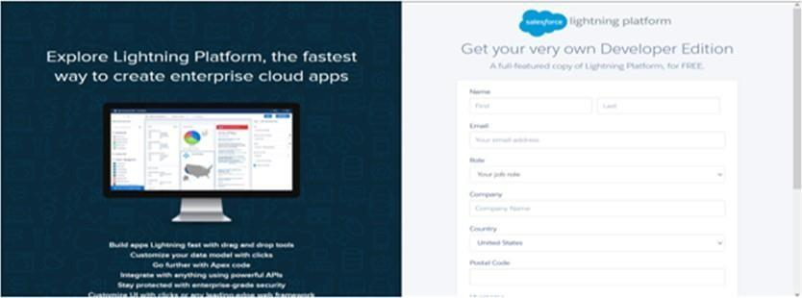

### Creating Developer Account

* Creating Developer Account
* Creating a developer org in salesforce.
* Go to developers.salesforce.com/Click on sign up.
* On the sign up form, enter the following details :
* First name & Last name
* Email
* Role : Developer
* Company : College Name
* County : India
* Postal Code : pin code
* Username : should be a combination of your name and company This need not be an actual email id, you can give anything in the format : username@organization.com
* Click on sign up after filling these.
* **Account Activation**
* 1.Go to the inbox of the email that you used while signing up. Click on the verify account to activate your account. The email may take 5-10mins, as  
    
  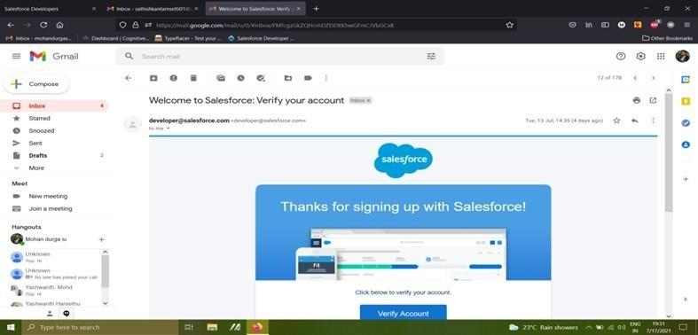   
  2.Login To Your Salesforce Account

**Object**

* What Is Object?
* Salesforce objects are database tables that permit you to store data that is specific to an organization. What are the types of Salesforce objects
* Salesforce objects are of two types:
* 1.Standard Objects: Standard objects are the kind of objects that are provided by salesforce.com such as users, contracts, reports, dashboards, etc.
* 2.Custom Objects: Custom objects are those objects that are created by users. They supply information that is unique and essential to their organization. They are the heart of any application and provide a structure for sharing data.

**Custom Objects - Enquiry, Property, Loan**

### Custom Objects-Enquiry, Property, Loan,  Create Enquiry Object

### To Navigate to Setup page To create an object: From the setup page ? Click on Object Manager ? Click on Create ? Click on Custom Object. On Custom object defining page: Enter the label name (lead), plural label name ?(leads), Record name(Customer Name) Click on Allow reports, Allow search ? Save

### Create Object Property

1)To create an object:  
2)From the setup page ? Click on Object Manager ? Click on Create ? Click on Custom Object.  
3)Enter the label name?Property  
4)Plural label name? Properties  
5)Record Name?Property Name  
6)click on Allow reports,  
7)Allow search ? Save

**Create Object Loan**

1.To create an object:  
2.From the setup page ? Click on Object Manager ? Click on Create ? Click on Custom Object.  
3.Enter the label name?Loan  
4.plural label name? Loans  
5.Record Name?Loan Id  
6.Data Type?Auto Number  
7.Display Formate?LN-{0000}  
8.Starting Number?0001  
9.click on Allow reports,  
10.Allow search?Save

**Tab**

What is Tab?  
A tab is like a user interface that is used to build records for objects and to view the records in the objects.  
  
1.Types of Tab  
2.Custom object tab  
3.Web tab  
4.Visualforce tab

**Create The Lightning Tab**

Create the Lightning Tab to create a Tab:(enquiries)  
  
Go to setup page ? type Tabs in Quick find bar ? click on tabs ? New (under custom object tab)  
  
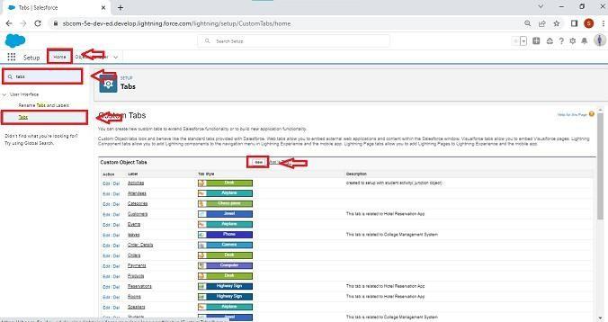  
  
Select Object(Lead) ? Select the tab style ? Next (Add to profiles page) keep it as default ? Next (Add to Custom App) keep it as default ? Save.  
  
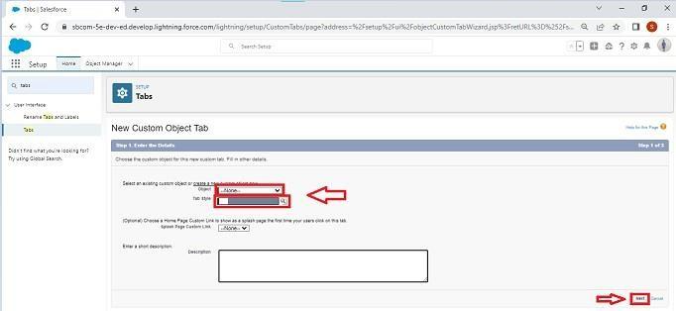

**Create A Tab ( Property,Loan )**

**To create a Tab:(Property**)  
1)Go to setup page ? type Tabs in Quick Find bar ? click on tabs ? New (under custom object tab)  
2)Select Object(Property) ? Select the tab style ? Next (Add to profiles page) keep it asdefault ? Next (Add to Custom App) keep it as default ? Save.Activity4:  
  
**To create a Tab:(Loan)**  
1)Go to setup page ? type Tabs in Quick Find bar ? click on tabs ? New (under custom object tab)  
2)Select Object(Buy) ? Select the tab style ? Next (Add to profiles page) keep it as default ? Next (Add to Custom App) keep it as default ? Save

**The Lightning App**

An app is a collection of items that work together to serve a particular function. In Lightning Experience, Lightning apps give your users access to sets of objects, tabs, and other items all in one convenient bundle in the navigation bar.  
Lightning apps let you brand your apps with a custom color and logo. You can even include a  
utility bar and Lightning page tabs in your Lightning app. Members of your org can work more efficiently by easily switching between apps.  
 **Create the Lightning App**  
  
Go to setup page ? search “app manager” in quick find ? select “app manager” ? click on New lightning App.  
  
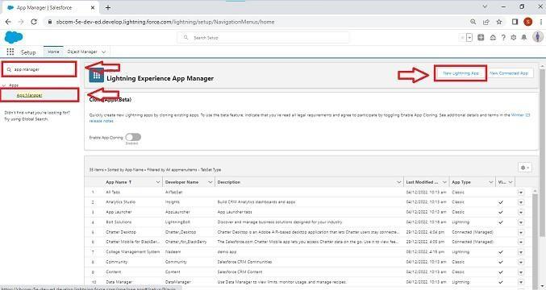  
  
Fill the app name as an Property Management in app details and branding ?Next ? (App option page) keep it as default ? Next  
  
  
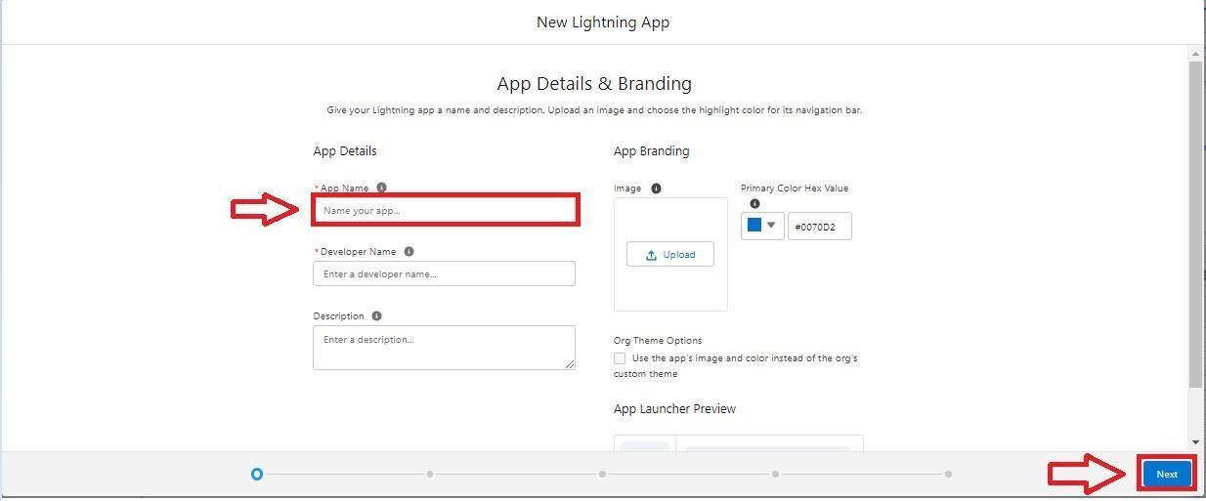  
(Utility Items) keep it as default ? Next ? (Add User Profile) Add System Administrator, Salesforce platform user, Standard User ? Next.  
  
To Add Navigation Items:  
( Lead, Property, Loan, Report, Dashboard) Select the items from the search bar and move it using the arrow button ? Next.  
  
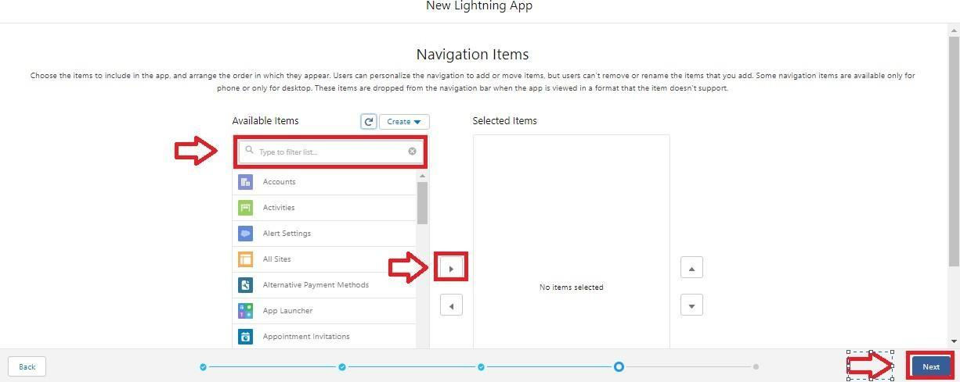  
  
To Add User Profiles:  
( System Administrator, Salesforce platform user, Standard User)  
Search profiles in search bar ? click on the arrow button ? save & finish.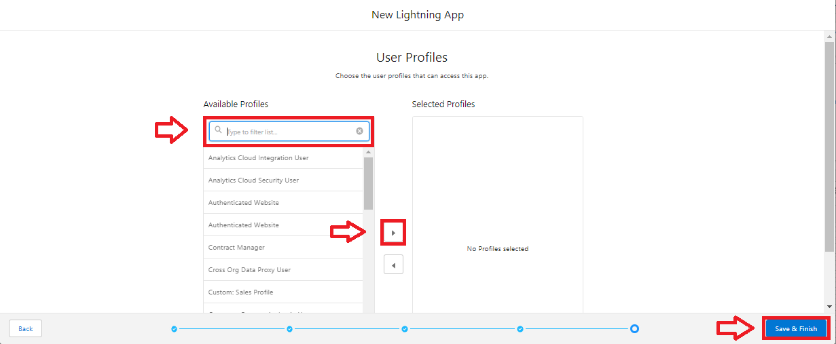

**Create The Lightning App**

Go to setup page ? search “app manager” in quick find ? select “app manager” ? click on New lightning App.  
  
  
  
Fill the app name as an Property Management in app details and branding ?Next ? (App option page) keep it as default ? Next  
  
  
  
(Utility Items) keep it as default ? Next ? (Add User Profile) Add System Administrator, Salesforce platform user, Standard User ? Next.  
  
To Add Navigation Items:  
( Lead, Property, Loan, Report, Dashboard) Select the items from the search bar and move it using the arrow button ? Next.  
  
  
  
To Add User Profiles:  
( System Administrator, Salesforce platform user, Standard User)  
Search profiles in search bar ? click on the arrow button ? save & finish.